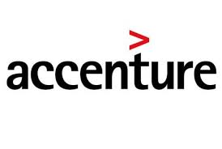

ValNav (Value Navigator)

Version 1.1

Abstract:
ValNav provides a packaged solution used by Repsol to Evaluate well and project economics, Forecast well and project outcomes, Estimate and Manage Reserves. Valnav application is hosted and supported in and supported by region.

Document Control Information
Document Reference:
Date: June 4, 2015

Approvals:

 | Name | Position
Author: | Sandeep Kumar Veeravalli/Srisailam Varma Danalakota | Accenture Consultant
Reviewer (s):
Approver (s):

Amendment Record:

Issue Number | Date | By Whom | Pages Altered/Comments

Document Distribution:

Name | Department

Referenced Documents:

Document Name | Document Reference | Folder link

Table of Contents:
1.0 Valnav Overview 6
1.1 Introduction 6
1.2 Environments 6
1.3 Two Environment Landscape 7
2.0 Valnav Infrastructure 8
2.1 ValNav Architecture 8
2.2 ValNav Databases 9
2.3 ValNav Interface Databases 9
2.4 ValNav License Information 10
2.5 Source code management 11
2.6 Servers 11
3.0 Backup & Disaster Recovery 12
4.0 Client Software 13
4.1 Packaging Information 13
4.2 Security groups 13
5.0 User Access for ValNav 14
5.1 Access provisioning flow 14
5.2 ValNav User Addition 15
5.3 ValNav User removal 15
6.0 Valnav Architecture & Interfaces 16
6.1 Valnav Architecture 16
6.2 Interfaces 17
6.2.1 Interface with SAP 18
6.2.2 Interfaces with other applications: 19
6.2.3 Interface dependencies 20
7.0 Application deployment 21
8.0 Incidents 22
9.0 Enhancements 23
10.0 Accenture in scope 24
11.0 Additional information 24
11.1 ServiceNow Information 24
12.0 Vendor Information 24
Appendix 1: Document References 25
Related Documents 25
Document Dependencies 25
Appendix 2: Document Information 25
Document Attributes 25
Revision History 25
Document Approvals 25

Valnav Overview

Introduction
Valnav is a vendor (Energy Navigator) supplied package solution that is used by Repsol business clients and North America Operations’ Development and Operational Engineers and NAO Commercial and Planning Analysts to:
  - EvaluateWellandProjectEconomics
  - Development Wells are modeled in WellSpring solution
  - Forecast Well and Project outcomes
  - Estimate and Manage Reserves

Environments
The Valnav Landscape at Repsol consists of two environments.
They are:
SR. No: | Environment | Description
1 | Test | All Migration and configuration testing are conducted in this environment. Unit testing and Peer review are performed in this environment.
2 | Production | Only production related tasks are performed in this environment. This environment follows change management process and only approved configuration changes will be deployed into this environment. The only changes made in this environment will be in the form of deployments.

Two Environment Landscape
As stated above, all changes in the environment originate and they are deployed to the other environments from test. The following diagram shows a logical flow of changes through the environments.
ValNav
Two Landscape Environment

Test
Production
Deploy

Image: ValNav – 2 Landscape Environments

Valnav Infrastructure

ValNav Architecture
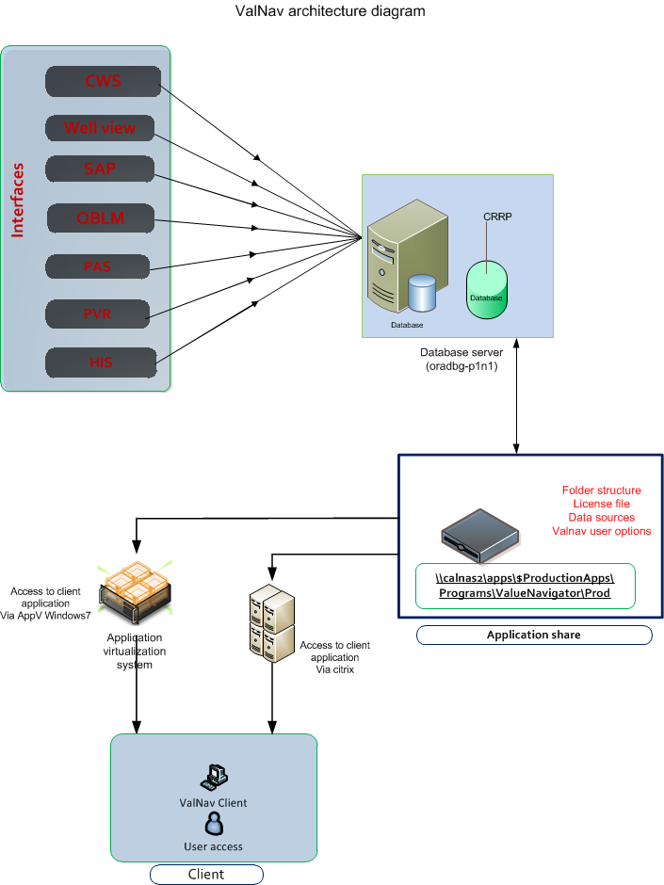

ValNav Databases
Following are the databases being used by the ValNav application.
 | Test | Production
Database Name: | CRRT | CRRP
Database Server: | oradbg-u1n1 | oradbg-p1n1
Database User Name: | NAUTAPP  ENNAV  ENSTAGING  ENTIBCO  IHSDATA  TLM_ENN | NAUTAPP  ENNAV  ENSTAGING  ENTIBCO  IHSDATA  TLM_ENN
Database Type | Oracle 11.2.0.4 | Oracle 11.2.0.4

ValNav Interface Databases

Following are the databases used for Valnav inbound interfaces:
CWS:
 | Test | Production
Database Name: | CWST | CWSP
Database Server: | oradbg-u1n1 | oradbg-p1n1
Database User Name: | QUERY | QUERY
Database Type | Oracle 11.2.0.4 | Oracle 11.2.0.4

WellView
 | Test | Production
Database Name: | WLVT | WLVP
Database Server: | caldev7 | oradbb-p1n1.tlm.com
Database User Name: | QUERY | QUERY
Database Type | Oracle 11.2.0.4 | Oracle 11.2.0.4

PVR:
 | Test | Production
Database Name: | PM5Test | PM5PROD
Database Server: | oradbg-u1n1 | oradbg-p1n1
Database User Name: | QUERY | QUERY
Database Type | Oracle 11.2.0.4 | Oracle 11.2.0.4

Envision:
 | Production
Database Name: | EYES
Database Server: | oradbb-p1n1.tlm.com
Database User Name: | QUERY
Database Type | Oracle 11.2.0.4

PAS:
 | Test | Production
Database Name: | PAST | PASP
Database Server: | pas-2a-p1n1 | pas-2b-p1n1
Database User Name: | pas | pas
Database Type | Oracle 11.2.0.4 | Oracle 11.2.0.4

QBLM:
 | Test | Production
Database Name: | QBLT | QBLP
Database Server: | oradbg-u1n1 | oradbg-p1n1
Database User Name: | TLM | TLM
Database Type | Oracle 11.2.0.4 | Oracle 11.2.0.4

ValNav License Information
The current ValNav licenses are valid till August 31, 2015 for 60 users.
Business analyst is the point of contact for License renewal. Upon receiving the new license code from the vendor, support analyst can extend the license from the front end application through License Manager Console.
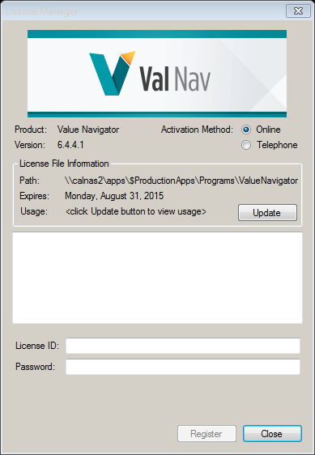

Source code management
ValNav is a vendor application and the application source code is not with the Repsol. However, the application media, Service setup files are maintained in the SourceGearVault repository.

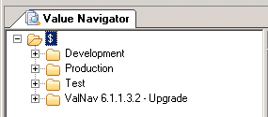

Servers

It’s client/Server architecture. The license file, configurations files and data sources are hosted in the share drive mentioned below. The client is designed to interact with the share drive to access these files.

- \\calnas1\APPS_TEST\$ProductionApps\Programs\ValueNavigator\Prod
- \\calnas2\apps\$ProductionApps\Programs\ValueNavigator\Prod

Backup & Disaster Recovery
The backup strategy for ValNav test & Production environments in Calgary will consists two types of backups. These are:
- Full back up: Every day at 8:00:00 PM MDT
- Archive log backup every 2 hours daily.
In case of Database crash, this is being backed up on a daily basis. We can restore using the backup.

Client Software
Valnav application is packaged and made available to end users on their desktops (via software center) and on citrix receiver.
- ValueNavigator 6_4_4_1

Packaging Information
The Valnav application is packaged as App-V for citrix and MSI for windows 7.
Package Details:
S No | ATEA No | Package Name | Packaging Method
1 | 5811 | Value Navigator-Test_Citrix2008(x64) | App-V 5.0
2 | 5808 | Value Navigator_PROD_Win7(x64) | MSI
3 | 5807 | Value Navigator_PROD_Citrix2008(x64) | App-V 5.0

Security groups
Below are the security groups for ValNav Application.
Users should be added to the application security group to obtain access to the share drive, get an icon in the citrix receiver and to install application from software center.
ValNav application security groups
1 | Development | Packaging groups | NA
1 | Development | Application groups | NA
2 | UAT | Packaging groups | grp-usr-pkg-ValueNavigator-UAT-na
2 | UAT | Application groups | ValueNavigator-test-aag
3 | Production | Packaging groups | grp-usr-pkg-ValueNavigator-na
3 | Production | Application groups | ValueNavigator-aag

User Access for ValNav

Access provisioning flow
Following is the work flow of service requests.
Users should submit service catalog request to get access to the ValNav application. After the request is approved, Accenture support team is involved in the user request for application then later ITAP team will add user to respective security groups

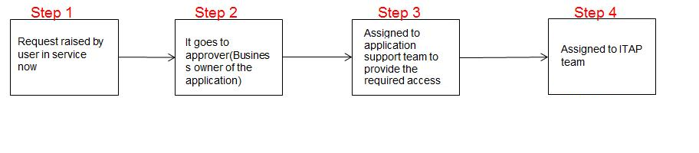
Image: Access provisioning flow for Valnav
To provide access to any folder in different environments of Valnav, user needs to raise request through Service Now
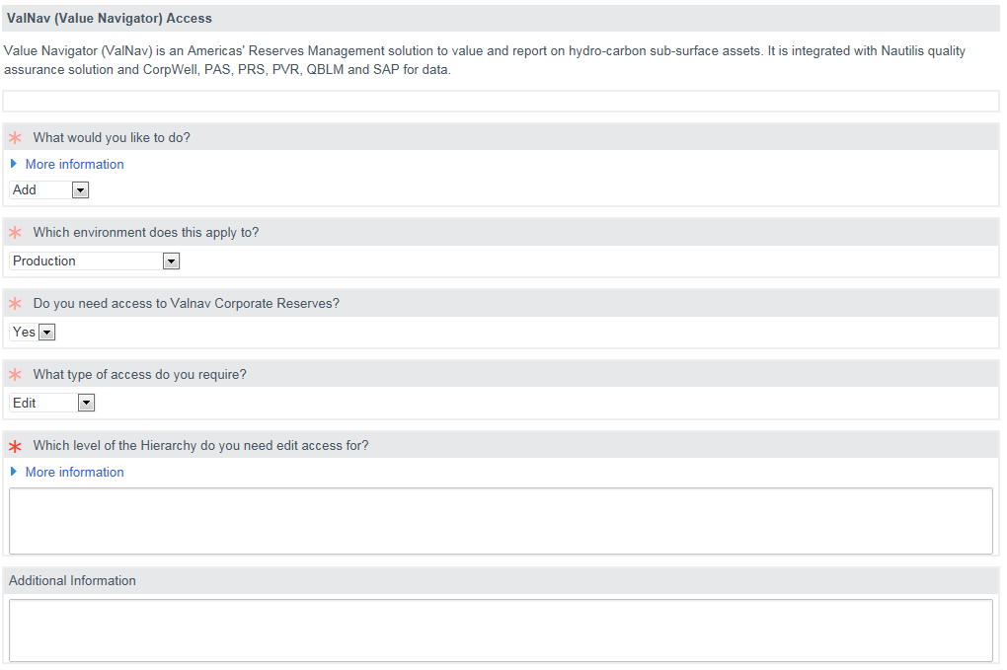
Image: Access provisioning screenshot from ServiceNow

ValNav User Addition
Two tasks will be created in service now to provision user access request. First task will be assigned to support team to setup user account in the application. After completion of first task, task 2 will be created with ITAP team to add user to application security group.
Steps | Activities | Team
1 | Send an email to ValNavTLMHelp team to create the user with the required roles in the application. | Accenture
2 | ValNavTLM team will send a confirmation email to support team | Business team
3 | Send a email to user that added to the ValNav application as once support team close the ticket it flows to ITAP team. | Accenture
4 | Add User to security group: (for which user requested) | ITAP team

ValNav User removal
Two tasks will be created in service now for user removal request. First task will be assigned to support team to remove user account from the application. After completion of first task, task 2 will be created with ITAP team to remove user from application security group.
Steps | Activities | Team
1 | Send a email to ValNavTLMHelp team to remove user from required roles in application | Accenture
2 | ValNavTLM team will send a confirmation email to support team | Business team
3 | After closing the task from support team end then the ticket will flow to ITAP team | Accenture
4 | Remove User from security group: (for which user requested) | ITAP team

Valnav Architecture & Interfaces

Valnav Architecture

Interfaces
Valnav application database (CRRP) has inbound interfaces with SAP, CWS, HIS, PASP/F, PVR and QBLM. Except SAP, all other applications are interfaced using DB links to ENSTAGING schema in CRRP database.
The ENSTAGING schema will capture the data from different inbound interfaces through database scheduled jobs, which in turn invokes stored procedures to refresh the materialized views to get the real time data from the source databases.
The data is then refined to use it in ENNAV schema (which is the application main schema) for corporate reserves operations.
The database scheduled job process is described in the below table.

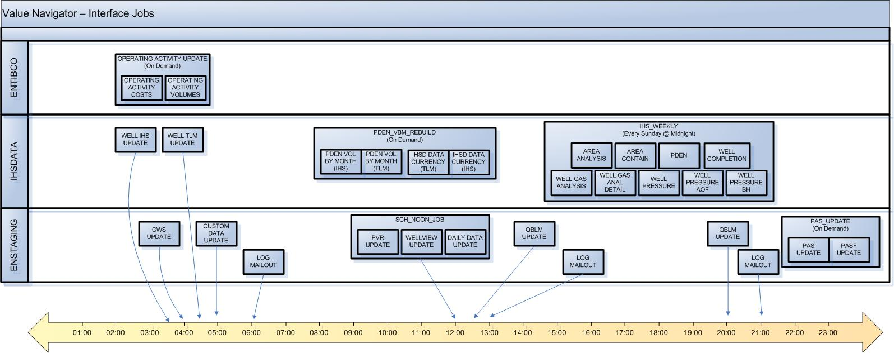

Interface with SAP

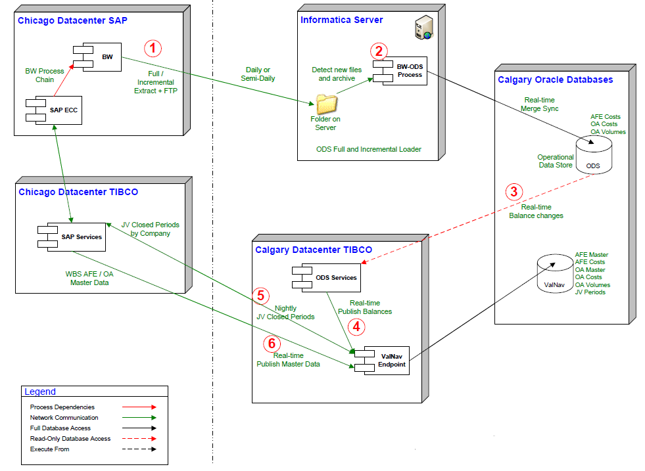

Interfaces with other applications:
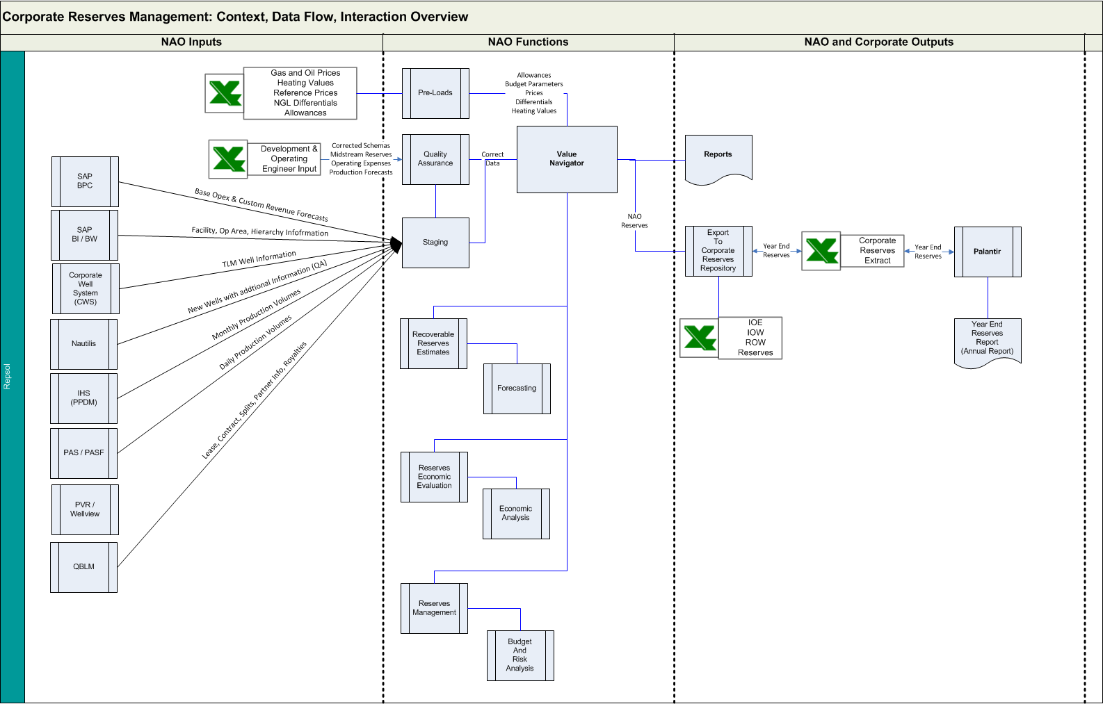

Interface dependencies

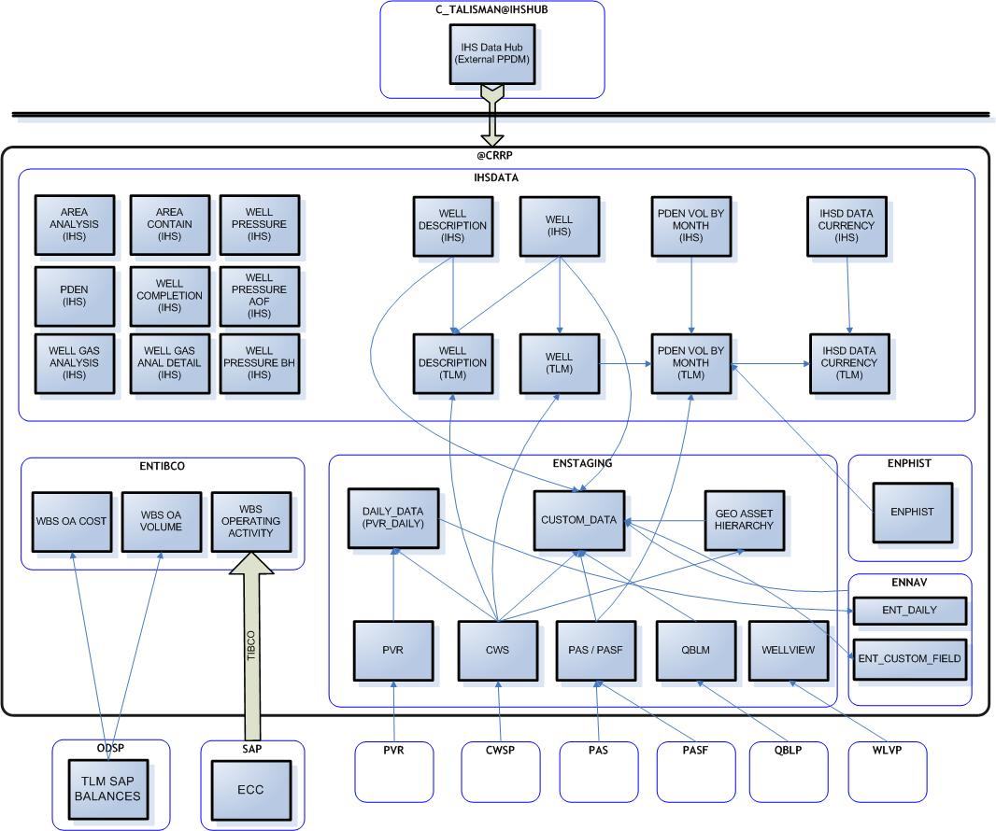

Application deployment
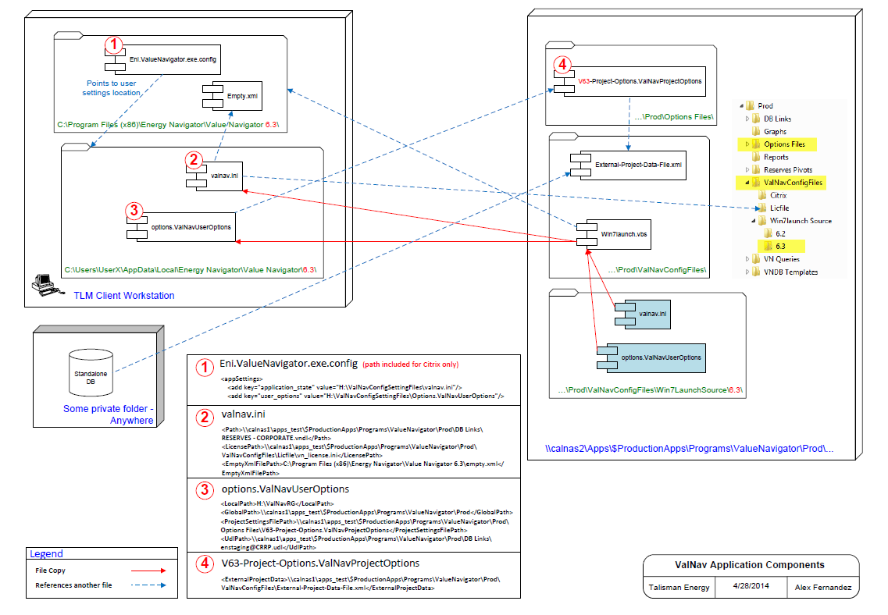
Image: Deployment instructions for upgrade

Incidents
Valnav application is used by Repsol in NAO region. User will submit tickets via service desk for any incidents/issue/Adminstrative tasks related to the applications.

Incident Number | Description | Resolution
INC0029189 | Valnav: Materialized view MVW_QBLM_RELATED_ITEMS is failing to refresh | The materialized view ‘MVW_QBLM_RELATED_ITEMS’ has UNIQUE INDEX on ‘PRIMARY_NB, SECONDARY_NB, CP_BUSINESS_OBJECT_TYPE_CD, RELATED_PRIMARY_NB, RELATED_SECONDARY_NB,  RELATED_CP_BUS_OBJECT_TYPE_CD’columns. For this column combination, the source table (QBLM) has two duplicate records and hence it is failing to refresh the materialized views.  Informed QBLM team about the issue and they have deleted the duplicate records in the source table. Now the interface is running successfully.
INC0025768 | The objects in CRRT, CRRD are not in sync with CRRP. | Database objects in CRRD and CRRT are cleaned to match with CRRP as requested.
INC0017871 | ValNav - program could not find a license file. | Issue is fixed by manually loading the license file on Alex machine.
INC0019123 | ERROR Statistics for ValNav. | Identified the corrupted record which is causing the stored procedure to fail. Rick has deleted the corrupted record from the application frontend to resolve the issue

Enhancements
Valnav application support team has worked on major & minor enhancements in application.
Some of the enhancements are listed below:
Enhancement Details | Description
Enhancement Title | ValNav - Nautilis version 6.4 upgrade
Requirement | This upgrade is required for to update new tables and procedures in the database and after upgrading the database need to repackage for to point out new share locations
Contact Person | Helfrich, Michael

Enhancement Details | Description
Enhancement Title | ValNav 6.4.4.1 Service Pack Upgrade
Requirement | This upgrade is required for new Repsol quarterly reserves reporting from 6.4version to 6.4.4.1 version successfully and packaged for the citrix receiver
Contact Person | Helfrich,Michael

Accenture in scope
- Coordination with business team for User Administration requests.
- Troubleshoot/Investigate on infrastructure/technical issues.
- Infrastructure changes/ Patching activities.
- Enhancements.

Additional information

ServiceNow Information
Service now is a ticketing tool, where users are able to submit tickets for Support team to resolve reported issue. Change Request related to Bug fix or Enhancements are raised in Service now tool and maintained.

Service Now Classification : Valnav
ITSM Classification : ValNav (Value Navigator)
ServiceNow assignment group for incidents/change tasks : ASGN-CENRTreasuryPlanningSCM-CACAL
ServiceNow assignment group for user access request : APPR-ITCorporate-CACAL
User access approval group : APPR-ITCorporate-CACAL
Change request approver group : APPR-ITCorporate-CACAL

Vendor Information

Energy Navigator Inc. is the vendor for ValNav application.
Need to take business approval before reaching out vendor for any application bugs: valnavsupport@energynavigator.com

- Document References

Related Documents
This section lists documents that relate to this procedure or provide additional information.
Document Name | Location/Link

Document Dependencies
This section identifies other documents that have similar information and may require updating if changes are made to this document.
Document Name | Dependency | Location/Link
- Document Information

Document Attributes
Attribute Type | Attribute Value
Document Owner | Enter the name of the person who is accountable for the accuracy of this document’s content. Typically, this is someone at a Team Leader level or higher.
Review Frequency | Select a review frequency
Reviewers | - List the Infrastructure teams or roles that should review this document when it is updated. Do not include specific names.

Revision History
Revision | Revision Date | Revised By | Description

Document Approvals
Name | Position/Role | Date | Signature

